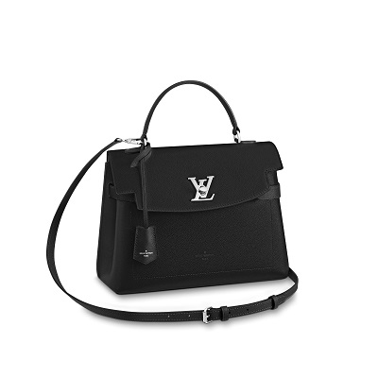

Lockme Ever Lockme

PRODUCT DETAILS

**- Black**

**- Sof t grained calfskin**

**- Sof t grained-calfskin trim**

**- Microfiber lining**

**- Silver-color hardware**

**- Top handle for hand or elbow carr y**

**- Removable, adjustable strap ( drop : min. 43 cm/16.9 inches, max. 49 cm/19.2 inches ) for shoulder**

**or cross -body carr y**

**- LV turn lock**

**- Key bell**

**- Flat pocket**

**- Double smartphone pocket**

**- 4 protective metal bot tom studs**